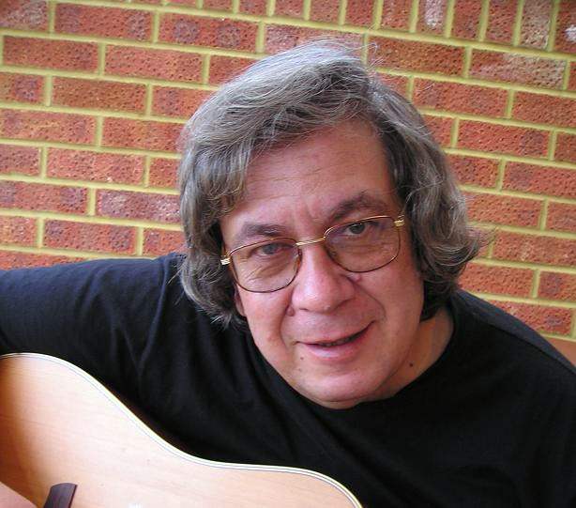
GEORGE PAPAVGERIS

Biography

“George is something special ” – Martin Carthy

“The best thing to happen in UK songwriting in many a year ” – Harvey Andrews

“The most prolific of creative men; the grandest of hearts and maker of songs that sear into the soul, George is unique, to say the least. His lilting accent lends a fantastic clarity to his delivery that is matched by deceptively simple guitar work. Few have written so many songs that demand your full attention and then insist, in the finest of ways, on staying with you forever”. (Graham Searle)

George’s stock-in-trade is quality songsmithery that everyone can relate to, rather than the more exclusive overt-confessional-soapbox mode that we often encounter. But he is not politically naïve, neither is his outlook without conscience; he just prefers lasting values to transient/parading activism, and takes genuine delight in simple pleasures.

George only began songwriting in 2001, but since then he has written 200+ songs and produced no less than eight CDs of his material. As an indication of the man’s quality, four of his albums were released on Robb Johnson’s Irregular Records (Ordinary Heroes & For My Next Trick) and UNLaBELLED Record labels (Silent Majority & Life As Usual), and with his last two, Life’s Eyes & Looking Both Ways, he entered the WildGoose stable. Additionally, more than a dozen of his songs are already covered by singers like Vin Garbutt, Andy Irvine, Roy Bailey, Jim Causley, Cloudstreet and Enda Kenny to name but a few. He has also made numerous appearances on UK and Australian radio and toured in Australia three times (2004, 2006 & 2008) including performances at the prestigious Australian National Folk Festival.

As a performer, George has a unique singing style. First impressions of gentility and understatement are quickly dispelled by his trademark passion and with his introductions he draws the audience effortlessly into his emotion-rollercoaster world. As a writer, he is driven by a love of people with all their imperfections, conveying the various issues and concerns with a healthy integrity and a deep folk sensibility. George is clearly conversant with a variety of musical styles and song forms, and his versatility extends throughout the many facets of folk music and types of song - from seasonal to the theory and practice of war, protest, industrial, vocational, social observation, local history/nostalgia, childhood memories, maritime, philosophical anthems and story songs. Now and then he also mirrors the music and rhythms of his native Greece.

A fitting epithet for his work might well be "songs for tomorrow's tradition", for make no mistake – George’s songs are putting down roots.

Recent festival appearances:
Sidmouth - Shrewsbury - Warwick – Saltburn – Chippenham – Cleckheaton - Fylde – Otley - Banbury – Wallingford - Bude – Broadstairs – Crediton – Dulverton – Gaisnborough - Wheaton Aston – Partick – National Folk Festival (Australia) – Yackandandah (Australia)

Discography: Looking Both Ways (2009) Life’s Eyes (2008)
For My Next Trick (2006) Ordinary heroes (2004)
Silent Majority (2003) Life As Usual (2004)
Countryside Like This (2002) Perfect moments (2002)

Website: www.folk4all.net Email: george@folk4all.net Phone: +44 7747 768868

